**Big Mountain Project Report**

**Problem:** What is the best pricing model for Big Mountain Resort tickets considering the number and property of resort facilities?

**Method:** We used a dataset that has 330 rows and 27 columns. The dataset contains information about 27 variables associated with 330 different resorts. After cleaning the data, we performed an exploratory data analysis to summarize and visualize the significant characteristics of a dataset. According to PCA results, we didn’t see any clear grouping between states so we decided to treat all states equally. We explored the relationships between features of resorts. We reserved 70% of the data for training and the remaining 30% to test. We chose the random forest model for determining ticket prices.

**Results and Recommendation:**

The Big Mountain Resort's actual ticket price is $81.00. Big Mountain’s ticket price is above the average of all resorts (see Figure 1), and the highest in Montana.

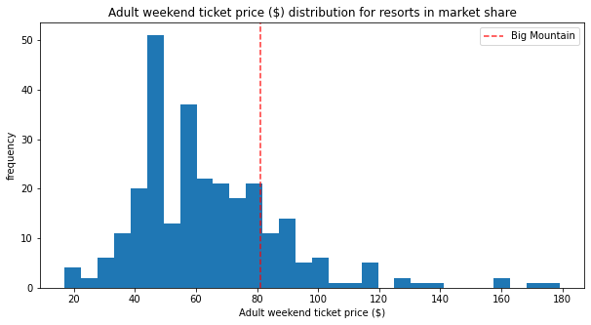

Figure 1. Ticket price ($) distribution for resorts in market share

Our modelled price is $98.48. Even with the expected mean absolute error of $10.31, this suggests there is room for an increase. Considering only the ticket prices of the resorts, it can be thought that the Big Mountain will place among the expensive and elite resorts and will be far from the average. This is not a threat to the Big Mountain because the resort is amongst the highest according to many important features when compared to other resorts. According to our model, these important features of resorts are the number of fast four person chairs (fast quad), count of the numbe rof runs, the area covered by snow making machines and vertical change in elevation from the summit to the base. We analysed where Big Mountain sits overall amongst all resorts for these features. Big Mountain is on the top table of snow making area. While most resorts have no fast quads, Big Mountain has three. There are some values much higher, but they are rare so Big Mountain is in top list. Also, Big Mountain compares well for both the number of runs and vertical drop but here are still some resorts with more, but not many. So we suggest the increase of ticket prices.

In addition to increasing ticket prices, cutting costs helps the increase in profit. We generated some scenarios based on our model. In these scenarios, we assumed that the expected number of visitors over the season is 350,000 and the average resort stay is 5 days.

If the resort closes 5 runs, the ticket prices decrease between $1.50-$2.00. Taking the maintenance cost of runs into, closing the 5 runs can be considered as an option to reduce the expenses. Also adding a run, increasing the vertical drop by 150 feet, and installing an additional chair lift increases support for ticket price by $2.22. Over the season, this could be expected to amount to $3,888,889. In this scenario, the building and operating costs should be taken into account.